INSTITUTION/CONTACT PERSON:
 | Last Name | Sbaih |  |  | First Name |  | Asma
Institution |  | Palestine Ahliya University College (PAUC)
Role in the institution |  | Coordinator, continuing educational centre
Address |  | Al Daher Mountain - Bethlehem
Town |  | Bethlehem |  | Country |  |  | Palestine
Telephone |  | +972598522650 |  |  | Email |  | asma_sbeih@paluniv.edu.ps
Homepage address of the institution |  | www.paluniv.edu.ps
INFORMATION ABOUT THE PLANNED PROJECT:
Erasmus+ International co-operation Activity (higher education sector) – type of the project idea |  |  | Please, tick the appropriate one/ones:  Erasmus+ KA1: International students and staff credit mobility  Erasmus+ KA1: Erasmus Mundus Joint Master Degrees  Erasmus+ KA2: Capacity Building Higher Education in Partner Countries  Erasmus+ Jean Monnet programme
Discipline / Academic field |  |  | Biological and Medical Informatics Research Center (BMIRC)
Institution’ s preferable role in the project?(applicant/partner) |  |  | Applicant  Partner
Which countries are about to be involved? |  |  | Erasmus+ Programme Countries |  |  | Member States of the EU
 |  |  | Erasmus+ Partner Countries |  |  | All National Erasmus+ countries
Working language of the project consortium = language of the project application |  |  | English,
Duration of the project |  |  | 2-3 years

PROJECT DESCRIPTION:
Biological and Medical Informatics Research Center (BMIRC)
The project proposes to establish a biological and medical informatics research center at Palestine Ahliya University within the ERASMUS+ project. The fundamental mission is to facilitate national and international dissemination of knowledge and experience in medical informatics and Telemedicine. This can be achieved by providing access to recognized experts and supporting partners in the field of medical informatics and Telemedicine worldwide.
Project justifications:
Developing this center can be justified by many reasons:
- Palestinian Universities lack this type of research center. Indeed, this center will be a focal point addressing several common diseases in Palestine.
- This center will create a knowledge database for each patient that can be used for further tasks, like investigate the treatment progress; perform some scientific research,…etc. So, this center would empower the applicant and partners to develop a medical record system in Palestine in order to improve its health care system.
- Medical problems such as cancer and heart diseases are widely spread in Palestine and worldwide. Therefore, addressing and diagnosing these diseases based on computational methods which include new machine learning methods and image processing techniques.
- Enhancement the Palestinian health care system, public health, consumer health and biomedical research.
- Presenting novel approaches based on new machine learning techniques and image processing algorithms can be beneficial to investigate such medical problems.
- Creating this center contributes in creating a collaboration platform between Palestinian Universities, Ministry of Higher Education, and hospitals to improve the health care system in Palestine.
Methodology and Procedures:

- It will focus on the causes of cancer diseases as they attack thousands of people in Palestine. Via a collaboration platform, the center and a pool of expert physicians will examine a set of cancer medical images to be deeply simulated and processed in order to provide a high quality and clear images of the affected body cells, 2D and 3D technology will be implemented as well. Further post-processing can be achieved, such as improving the segmentation results and computing the segmented cancer area which can be used as a factor for investigating the progress stages of treatment.
- The research center addresses another important medical problem, the ECG disease. ECG disease is one of the most dangerous diseases in Palestine and few specialist physicians can be found in nearest cities in Palestine. For instance in Bethlehem, there is no heart specialist can deal with emergence cases. Therefore, offering a computerized system, precise high quality ECG charts, disease coefficients and all the necessary information will be very useful to accommodate the non-specialist physicians to understand the causes and to correctly diagnose the affected parts. The center will deploy a portal web site to distribute its data and information to the public.
- This center will be a research medical reference for all medical institutions.

Project philosophy and vision are:

- Promote & Support medical informatics/Telemedicine activities nationwide and worldwide.
- Networking with national members and international Telemedicine and medical informatics community.
- Create a focal point for medical informatics needs and latest research and play a pivotal role in improving the health care system in Palestine and the region.
- Organize and support related events and scientific conference.

Project objectives:
- To carry out and promote the carrying out of medical informatics research designed to alleviate disease among the people of Palestine and partner countries;
- To carry out and promote the carrying out of research into various aspects of medical informatics.
- To cooperate with the Palestinian government, or body of persons, in promoting or providing facilities for, the training of local personnel for carrying out scientific research into medical problems and implementing technology on them.
- To monitor, control and coordinate medical research carried out within Palestine and the region.
- To establish a centralized registration computational system for Medical records in Palestine, clinical Data Base and Hospital/health information systems.
Research areas:
The following figure shows the different research areas that can be addressed and investigated within the medical informatics research center.
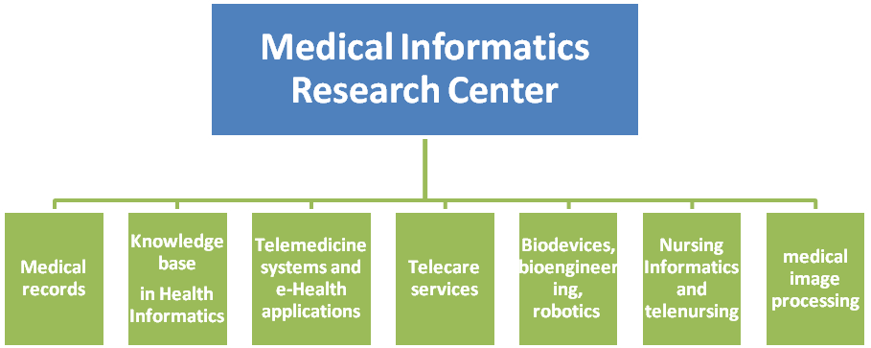
Figure1: Center structure.

